CS5200: Programming Assignment 2 (50 points)
In this assignment, you will learn and implement CRUD(Create, Read, Update, Delete) operations for personal notes management system using SQL commands connect to DBMS such as PostgreSQL, MySQL, SQLite3, DuckBD, …, etc. These are the basic APIs to perform at most functions on web applications. You will develop the backend web framework using Python Flask, Java, NodeJS, C# .NET,…, etc. connect and update the database using SQL commands. And also develop the frontend web interface so you can use any tools such as streamlit, gradio, javascript, react, angular, …, etc.
The application must support multi-users. First, the user registers by entering the username and password store on the users’ table. After that the user connects to LLMs (Large Language Models) and the user can do CRUD operations with the personal notes store on the notes table using natural language. You can use only open-source LLM models such as Ollama, LM studio,…, etc. no use any proprietary LLMs such as ChatGPTAI,…, etc.
The database includes:
Users ( user_id(PK) , username, password, last_login(date-time) )
Notes ( note_id(PK), user_id(PK, FK), topic, message, last_update(date_time) )

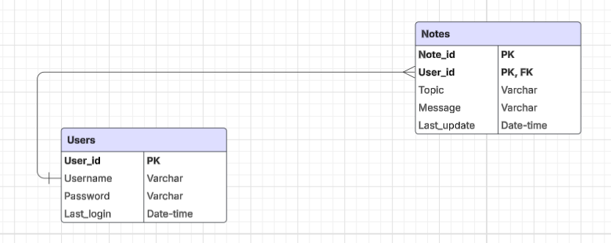

The are some videos on Brightspace talk about LLMs and usage. You can check the videos for introduction to LLMs. You should use the AI framework orchestras such as Pydantic, Llama index, LangChan, LangGraph, …, etc. The instructor will guide you on how to use it in the assignment.
Submission:
Turn in your codes and data files in folder name “PROG_ASSIGN2_XXXXX_YYYYYY” where XXXXX is course number (CRN) and YYYYYY is 700# student id and zip the folder before submitting your assignment.

Notes: (Please read it before starting the assignment)
If you want to use other platforms beyond Apollo Server. You must contact me beforehand and let me know how to use the platform. You can use internet cloud application platforms such as Heroku (https://www.heroku.com) if you prefer. However, in your assignment submission, you must provide me with the links for executing the application and source code. You are very welcome to use any LLMs chatbot such as ChatGPT, Gemini, Grok, Claude, …, etc. with any LLMs tools to help for coding such as Copilot, Cursor AI, …, etc. In the zip file submit folder you have to include the document to instruct me how to execute the application what is LLMs you use for the assignment. Please contact me if you have any questions or concerns.

